Lou _ Tool Year 2 Week4 ,20 March 2018

Week 4 – Tools, Software and Systems: Year 2 Homework

HOMEWORK:

- Finalize website content

- Collect Website Content

- Find images / normalize format/size

- Draft website text

- Make a list of any external links

Website content

This is Lou's personal website. A website sharing art works, art video and art notes.

这是Lou的个人网站。一个分享艺术作品，艺术视频和艺术笔记的网站。

Web plate

1.Home首页

2.Works作品

3.Videos视频

4.Notes笔记

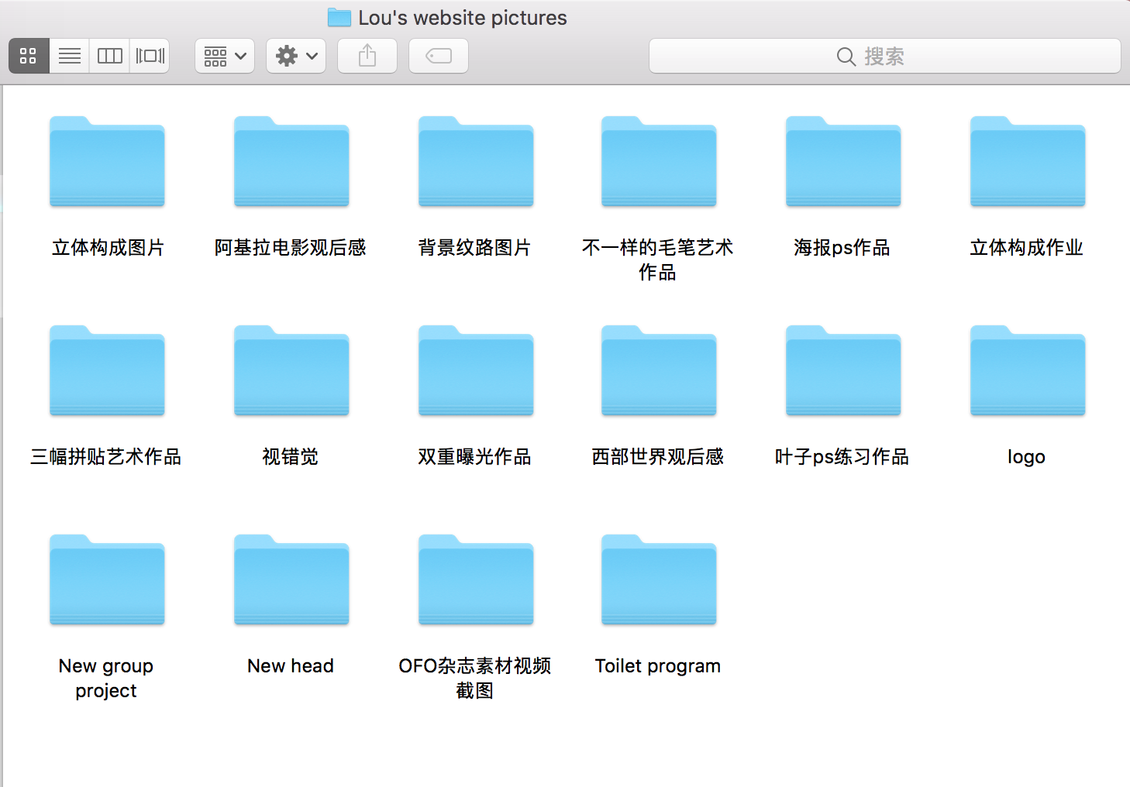

These are some of the pictures that I have collected, which can be put in Home and Works.

For example:

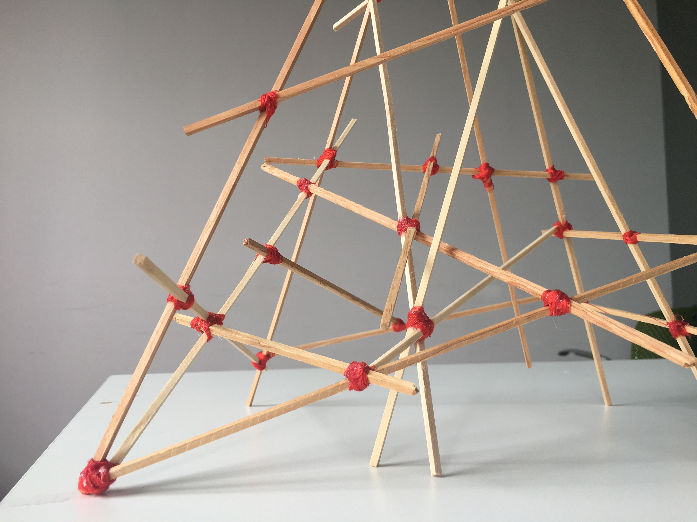



Links:

<link rel="stylesheet" type="text/css" href="style1.css">

Videos:

<http://www.beeple-crap.com>

<http://www.kaiyanapp.com>

<https://www.youtube.com/>

Notes:

<https://www.pinterest.com/>

<https://movie.douban.com>

<https://dribbble.com/>

<https://codepen.io/>